1. What is RDBMS?

Ans. The software used to store, manage, query, and retrieve data stored in a relational database is called a relational database management system (RDBMS).   
Relational Database Management System (RDBMS) is a more advanced version of a DBMS system that allows access to data in a more efficient way. It is used to store or manage only the data that are in the form of tables.

2) What is SQL?

Ans. SQL stands for Structured Query Language. SQL is a standard language for storing, manipulating and retrieving data in databases. SQL allows you to access and manipulate the databases.

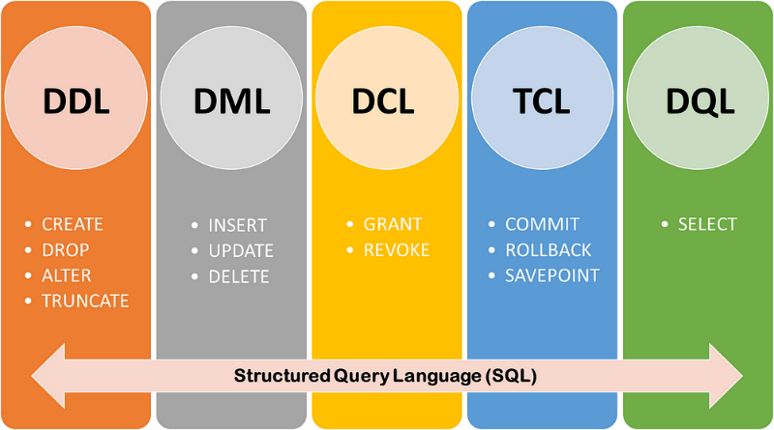  
3) Write SQL Commands?

Ans. SQL Commands are Categorized into five Categories.   
DDL: Data Definition Language

DQL: Data Query Language

DML: Data Manipulation Language

DCL: Data Control Language

TCL: Transaction Control Language

1. What is JOIN?

Ans. A JOIN clause is used to combine rows from two or more tables, based on a related column between them.

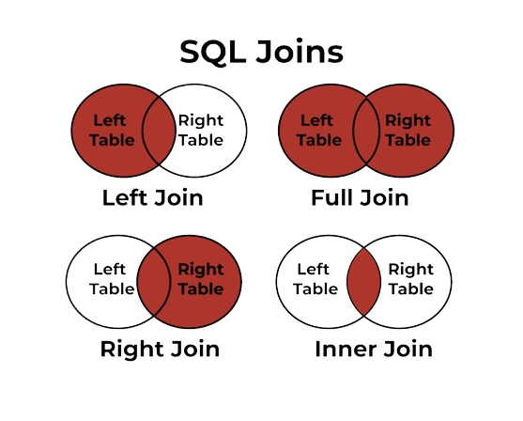

1. Write type of joins?

Ans. Here are the types of SQL Joins.

1. Left Join: Returns all records from the left table, and the matched records from the right table.
2. Right Join: Returns all records from the right table, and the matched records from the left table.
3. Inner Join: Returns records that have matching values in both tables.
4. Full Join: Returns all records when there is a match in either left or right table.
5. 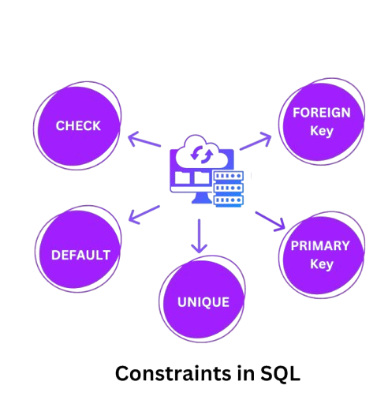How Many constraint and describes it self?

Ans. The following constraints are commonly used in SQL:

1. Primary Key: A combination of a NOT NULL and UNIQUE. Uniquely identifies each row in a table.
2. Foreign Key: Prevents actions that would destroy links between tables.
3. Check: Ensures that the values in a column satisfies a specific condition
4. Default: Sets a default value for a column if no value is specified.
5. Unique Key: Ensures that all values in a column are different.
6. Difference between RDBMS vs DBMS?

Ans.

|  |  |
| --- | --- |
| RDBMS | DBMS |
|  |  |
| [DBMS](https://www.geeksforgeeks.org/introduction-of-dbms-database-management-system-set-1/) stores data as file. | [RDBMS](https://www.geeksforgeeks.org/rdbms-architecture/) stores data in tabular form. |
| Low software and hardware necessities. | Higher software and hardware necessities. |
| No relationship between data. | Data is stored in the form of tables which are related to each other. |
| It deals with small quantity of data. | It deals with large amount of data. |
| Security is less. | More security measures provided. |
| It supports single user. | It supports multiple users. |
| Examples:[XML](https://www.geeksforgeeks.org/xml-basics/), Window Registry etc. | Examples: [MySQL](https://www.geeksforgeeks.org/architecture-of-mysql/), [SQL](https://www.geeksforgeeks.org/what-is-sql/) Server, Oracle, Microsoft Access etc. |

1. What is API Testing?

Ans. API Stands For Application Programming Interface. This Testing the business logic of any application is called API. QA will test the same logic and called API testing.

1. Types of API Testing?

Ans. Three types of API Testing.

**Open APIs:** These types of APIs are publicly available to use like OAuth APIs from Google. It has also not given any restriction to use them. So, they are also known as Public APIs.

**Partner APIs:** Specific rights or licenses to access this type of API because they are not

available to the public.

**Internal APIs:** Internal or private. These APIs are developed by companies to use in their

internal systems. It helps you to enhance the productivity of your teams.

1. What is Responsive Testing?

Ans. Responsive testing involves how a website or web application looks and behaves on different devices, screen sizes, and resolutions.

1. Which types of tools are available for Responsive Testing?

Ans. Many Tools are used for responsive testing like LT Browser, Lembda Testing, Google Resizer, am I responsive, Pixel tune.

1. What is the full form of .IPA, .APK?

Ans. IPA Stands for IOS Application Package,  
 APK Stands for Android Application Package

1. How to create step for to open the developer option mode ON?

Ans. To enable developer options on an Android device, you can follow these steps:

1. Go to Settings.
2. Select About phone or About device
3. Tap Software information
4. Tap Build number seven times
5. Enter your PIN, pattern, or password to enable the Developer options menu
6. The "Developer options" menu will appear in your Settings menu.